Entertaining Angels: A Story of Compassion
by Natasha L. Polak
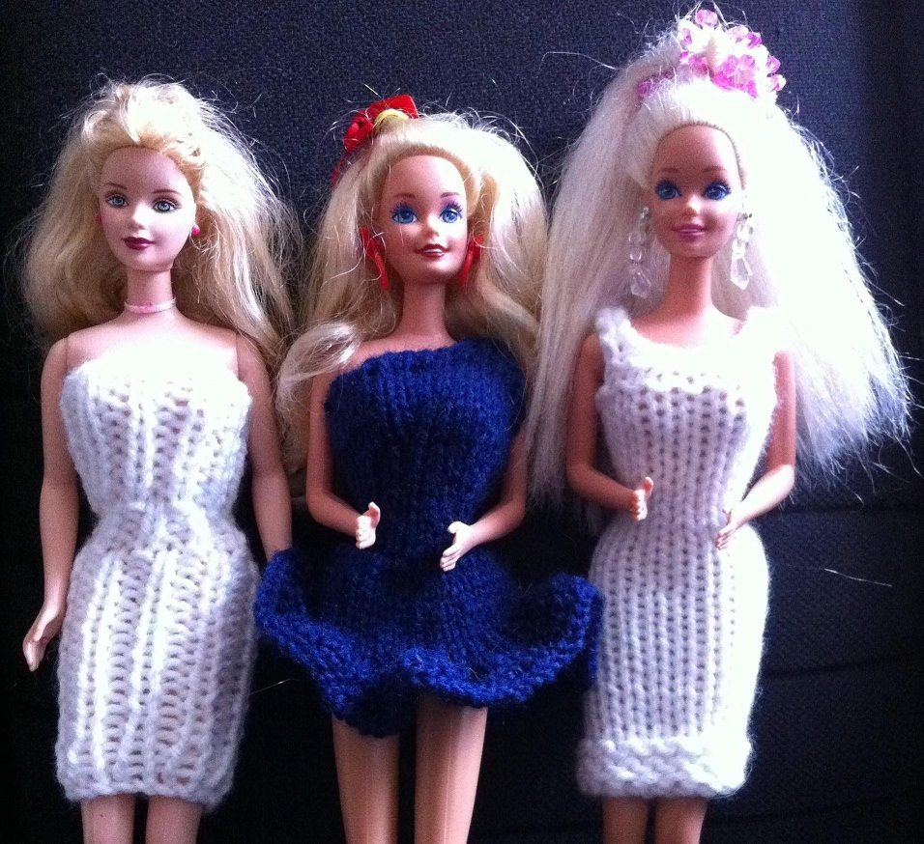

Introduction
My entire childhood took place in the 1980’s. It was a time when toys were plentiful, especially Barbies, and they were a big part of my playtime. Through the dolls, I began to develop a deep appreciation for girl power, beauty and fashion (though I’m sad to say neither of those traits rubbed off on me!!), and storytelling. Acting out life through my dolls was a therapeutic way for me to work through things I had going on, and so it was natural for me to take my entire collection of dolls on vacation when my parents and I went overseas to visit family. That visit would go on to become an adventure that defined my future. I hope that as you read the telling of this story, you too will be inspired by the things in your own life which could be used in limitless ways for helping others in need.
With God’s blessings,
Natasha
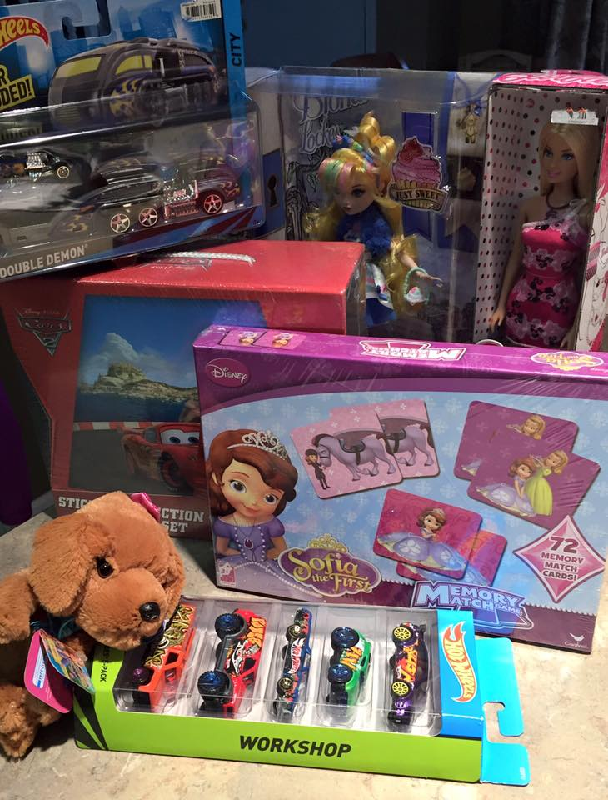

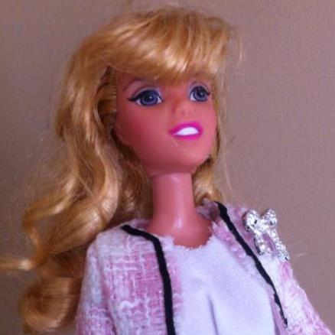
Surrounded by Dolls
The year was 1987, I was an impressionable 8 year old, going from my comfortable life in the U.S. to the third-world country of India, which back then was at least 10-20 years behind in terms of technology and entertainment – including toys. So from the day on which I pulled out my Barbies from my suitcase, no one there had ever seen such dolls before. These little women-dolls were intriguing to youth and adults alike, and led to many a conversation because of them.
“What do you do with them?”
“Why are their clothes so fancy?”
Such were the questions I would often receive. Each time, they were as comical as they were surprising to hear asked.
Never had I given any thought to what kids on the other side of the world had or didn’t have. I only knew that life was different for them through language and food alone, and for that I was only partially prepared.
To say that I was culture-shocked when I arrived in Chennai (Madras, back then) was an understatement. I knew nothing besides English, had only on occasion eaten Indian food, and my idea of spending a weekend or vacations away from school was to watch cartoons and play with my dolls and Care Bears, or pretend my friends and I were Jem and the Holograms characters.
So there I was, spending Summer vacation with my relatives I had never met before, caught in a confusing time warp where the only thing that made sense were my cherished toys, since I quickly found myself playmates my age. If anyone was looking for me, I was likely playing with my dolls or reading a book. But through sharing my dolls with others, my shyness began to melt, and I became more open to learning about the people around me I had so blatantly misunderstood.
My first encounter with another youth (other than my toddler cousin) was with a family who lived next door to my grandma. The compounds were separated by side yards, with trees bearing mangoes, coconuts, drumsticks, and bananas, in addition to bushes of hibiscus interspersed at random throughout the perimeter of both properties. I would take my dolls outside for picnics and strolls around the vegetation – after all, Barbie and her friends were on holiday, too!
It was during one of those blissful times that my dolls caught the eye of the girl who lived in that next door house. Her name was Lena, and although she was a good 8 years older than me, she had some mental disability that put her on the same level of understanding with someone my age, and was fascinated by my dolls and instantly became my friend. Over the course of the next four months, we truly hit it off. Sometimes she would come over to help brush my dolls’ hair or else she’d simply dress them in the clothes I’d brought along with me.
Then came the Christmas season, and we were still in India. Frustrated I was at my parents’ decision that ultimately changed the course of my life, I prepared for my first Christmas without Santa. At the time, I didn’t know that was going to be the case – that and the tooth fairy were two things my parents had kept me believing up until then, and before we ended our vacation a year and a half later, both of those beliefs would be shattered.
So back to that first Christmas away from my homeland. There I was, a lost and lonely 8 year old, anticipating Santa’s arrival in those few days before the holiday. I voiced my concerns about whether or not Santa could make it in his sleigh. While I don’t remember my parents’ exact words on the matter, they did try to assure me that I had nothing to worry about. But here’s what happened.
After spending a different sort of Christmas Eve that did not include the opening of any presents (for in those days and in that part of the world, gift-giving was not as widely practiced, other than sweet treats and small trinkets). More frequently, people wore special tailored outfits they had custom-made for the occasion, went to church if they were Christian, and enjoyed a good meal with family and friends. They’d fry up Danish rose cookies and kull-kulls and share them with one another. Oh, and there were the decorations! Most homes would have the beautiful practice of putting up a paper “star” to cover their outdoor porch-light to signify the home’s participation in the holiday. These stars were similar to paper lanterns, and truly breathtaking to see outside homes as you walked the street at night. Christmas trees were also decorated, but they most resembled a Charlie Brown Christmas tree – a spindly sort that was a large branch held up by being stuffed into a large flower pot – at least, that’s how it was for my family. It included some basic sorts of decorations of tinsel and ornaments, and that was it.
I remember going to sleep somewhat skeptical and worried that night, but I was still eager to find out what Christmas Day held. But when I awoke, it was as if the world stopped. Marudur Gopalan Ramachandran, or MGR, the Chief Minister for Tamil Nadu (the region where we were), had passed overnight – which meant the city was in mourning. No stores were open, and anyone who hadn’t already shopped for presents for loved ones were out of luck – my family among them.
When I grasped the magnitude of the situation, I’m ashamed to say that my reaction was one of devastation. It meant no presents at all! For, my family was often last-minute for gift-giving as it is, but this totally caught them unaware, and all they could say was that it was just another day. And just when I didn’t think it could get any worse, my mother pulled me aside and said that it would be a nice gesture if I could give away one of my dolls to the neighbor girl.
At first, I was unwilling to do such a selfless gesture. I was mad, spiteful, and confused. Embarrassing as it is for me to admit, I was throwing a pity-party, and the last thing I wanted to do was to do something nice for someone else when I wasn’t getting anything in return. Never before had I done anything of that kind, and I wasn’t about to start, either.
At the back of my mind, however, I felt the push to listen to my mother (and as my mother knows, she’s not someone to be reckoned with!). So with great hesitation, I finally chose a doll I felt I could part with (and really, it was also one that Lena had already gravitated toward on more than one occasion), and together with one of my relatives, we went over to their house to give Lena so that she would have the gift of a toy for Christmas.
We were greeted by Lena’s older sister, who took the doll on our behalf to give to Lena later that day when she woke up. So we talked for a little while with her sister, conveyed our Christmas wishes, and went back home.
Within a few hours, Lena rushed over. As it turned out, from the moment she received my doll, she was so touched by the gift, that although her parents had given her a baby doll as her one Christmas gift they’d been able to purchase ahead of the holiday, she felt compelled to give it to me, instead! Never before had I witnessed such selflessness, and I was completely blown away by her gratitude.

A Second Opportunity
Eventually, there came a second occasion during my India trip where I got to give away another doll. This time, it was to a distant cousin of mine, who was the same age as me, but didn’t have the best home life or have any dolls. Naturally, she gravitated towards my Barbies. Here again, my mother pulled me aside to suggest I give her one of them.
You would have thought I wouldn’t have been resistant to gifting a doll again, and yet I was. I actually was a little worried my mother would have me give away all of my dolls until I had none left to take back home! But then I was reminded that this poor girl had no mother, and was often forgotten among her siblings and somewhat detached father. And so, looking to help her find a little happiness, I listened and gave her a doll.
And you know what? This time when I did that, the experience hit upon an entirely different emotion for me – one of filling a need that I didn’t even know was there. Although I didn’t have another instance where I would give away another Barbie for the remainder of my trip, it definitely changed my perspective on things. I’m glad it did, otherwise I wouldn’t have gotten through what happened next.
Whatever we hadn’t been able to take with us to India or store at my aunt’s house in the U.S. while we were away had been put in storage. In an unfortunate set of circumstances that ended with the storage owner being unable to reach us, all of our possessions were auctioned in the fall of 1988. It was as if we had suffered a catastrophic house fire or flood overnight when we’d heard the news. But that was when it also hit us just how futile this life is, and we’d had no choice but to come to grips with what had occurred. That’s when I learned how to see my stuff as just things. At the end of the day, they didn’t own me. What became more important to me were my faith and the people in my life with whom I needed to make memories. And I never looked back.
New Beginnings
It’s funny how complacency creeps in when you’re not paying attention. After several rough years of moving, leaving behind old things and buying new things, and repeating the process over and over again, my life took another twist when we moved cross-country from East Coast to Midwest.
By then, it was the mid 1990’s, and my interest in Barbie dolls hung on until my teens. While I had played with them less, I still enjoyed collecting them and fussing over them. Eventually the dolls and their trunk-load of accessories were packed away, with the hopes that I would one day have a little girl of my own who would cherish them as I did.
In 2004, I became the mom to a daughter – and was I thrilled! Sharing my dolls with her was going to be so much fun! She was still a bit too young for them in 2007, but that was when I’d started as a volunteer newsletter writer with The Cheerful Givers, a nonprofit that exists solely to provide children in need with birthday gift bags. Their unique and specific cause appealed to me on many levels, but the connection between that idea and my childhood experience didn’t happen until 2009, when my daughter was just starting kindergarten.
Also that same school year, my husband and I got hit hard that year with trials that I fully believe needed to happen so we could be right where we are today. It was as if everything bad that could happen, did: I discovered a breast tumor (fortunately it was benign, but it was the first of two phylloides tumors I would have recur 3 years later), the economy took a nosedive, my husband had to close his business he’d just started only 48 months or so before, we had my medical bills and everything else still due, our house was on the line, and eventually we had no choice but to apply for Food Stamps.
Now, let me tell you something about Social Services. Being a recipient of their programs really was an eye-opener, because in going to their office to meet with our caseworker, it was like a whole other world – literally. There was a packed waiting room full of down-on-their-luck people from all lands. Some looked sick, others just looked depressed. It smelled in there – stale air, body odor, and cultural foods all combined as one. I saw lots of immigrants, many of them children and young mothers. I was floored by the overwhelming sadness and confusion that abounded in the room, a place where people anxiously awaited knowing if they would be able to provide for their families and themselves.
It also reminded me that despite my parents being immigrants themselves, they fought to keep afloat – which by today’s standards would have meant they would have easily been sitting in a room like this one, too, but somehow, we never had to worry about that. Sure, we had odd accommodations at times in between apartments – such as when we lived at a State Park campgrounds, a church, or with friends and family – but we never were without food on the table or clothing to wear. If anything, my parents often sacrificed a lot of their own needs just to ensure all of mine were met. It was something that I never fully grasped until I sat in that waiting room.
Right then and there, I made a promise to myself that if and when we got through this rough patch, I wanted to be able to help families so they could have hope – especially their children. And the idea grew.

Barbie Gift Bags
In 2011, so many things were happening throughout my local community – government funding for supplemental education was ending, housing needs were rapidly increasing, and an overwhelmingly large population of families within our school district were living in poverty. It was also when I recognized the fact that my daughter was just a year shy of how old I was when I first gave away a Barbie doll, and that made me think – why not have her experience that, too? By giving something of hers away, the giving would mean a whole lot more. And thus the idea for The Barbie Girls Project was born.
As the holiday season approached, I casually asked the principal at my daughter’s school how many students were in great need, and was saddened to hear the total numbered in the hundreds. Thinking quickly about what meager funds I had to contribute, I then went back to the principal and asked if he could pick out the neediest 10 girls, and we would make them what we referred to as “Barbie Gift Bags.” Each gift bag would contain a gently used doll, two changes of clothing, and fun accessories like stickers, trinkets, or Barbie-sized pets. He agreed, and we got to work. Some of the clothing, I knitted, while other outfits were store-bought or they came from what we already had.
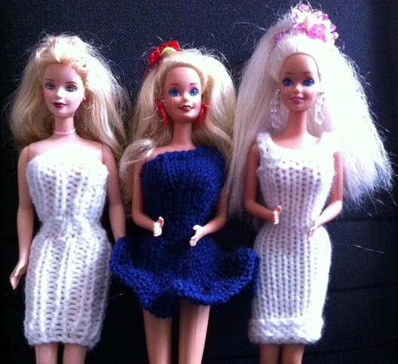
When the day finally came to give the unsuspecting girls their Christmas gifts, it was the day they were being dismissed for their two-week break, and I had asked that we remain anonymous to the recipients. However, as luck would have it, my daughter actually happened to be at the right place at the right time after school, and saw one of the dolls being presented to someone she actually knew. Excited, she couldn’t refrain from letting the girl know that it had come from her. In response, she received a tearful hug from her friend, all which served to do exactly what I’d hoped – it planted a seed of compassion. I knew that it as something we’d just have to find a way to repeat again.
Our next opportunity came that following holiday season, when a neighboring town experienced a horrifying home explosion that resulted in 2 people dead and several families displaced. The community at large rallied around the victims and neighbors to help collect all sorts of things to help them in their time of need. A friend of mine was a volunteer with the Indy Fire Rescue House and mentioned a call to action that got me thinking – could any of those families, or those for whom they keep a ready supply of provisions on-hand for as needs arise, use Barbie gift bags? I decided then and there that this would need extra hands to help. It was the perfect opportunity to enlist the girl power of the Girl Scout troop my daughter had recently joined! Our combined efforts amassed just over a dozen gift bags, stirring a continued interest in making that our annual holiday service project.
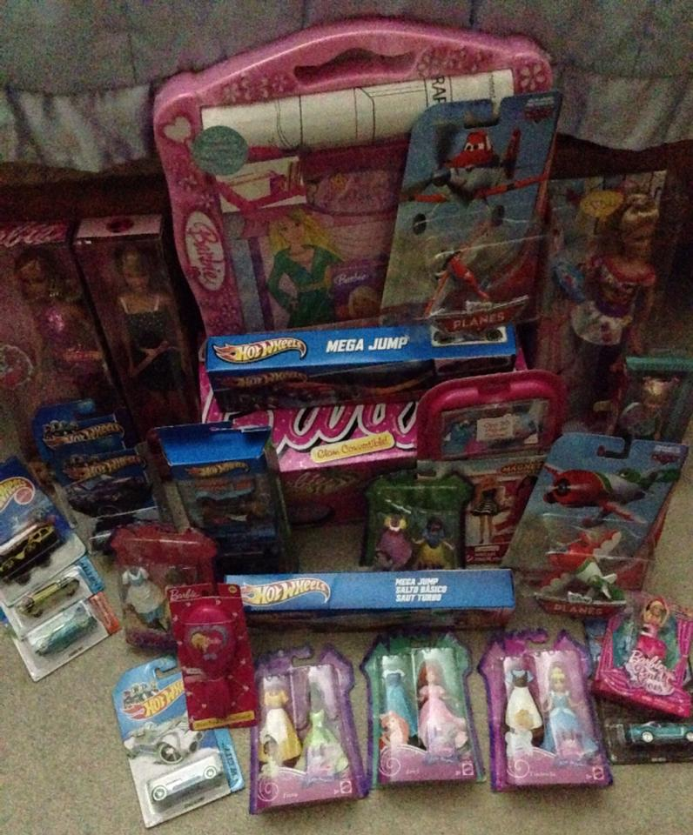
But when 2013 rolled around, my mind went back to a school flier that I’d once seen mentioning the need for Halloween candy and goodies for hospitalized children at Peyton Manning Children’s Hospital. It was something I’d taken note of to revisit at a later date. Obviously, gift bags of any kind were out. And then it hit me – what if we donated new-in-box Mattel toys – that way girls and boys would benefit from our help, instead? The idea was met with the enthusiasm, and our first toy drive effort was a modest success of over 20 toys.

Niche Market
I desired to expand The Barbie Girls Project’s reach just a bit in 2014. Could we go global? I tried, but plans fell through. Despite numerous inquiries around town, I was actually getting told by several organizations that they’d had “enough” toys for children, or simply didn’t want an additional partner at that time. Frustrated, I sat that year out, waiting, planning, and hoping that this didn’t spell the end of our project!
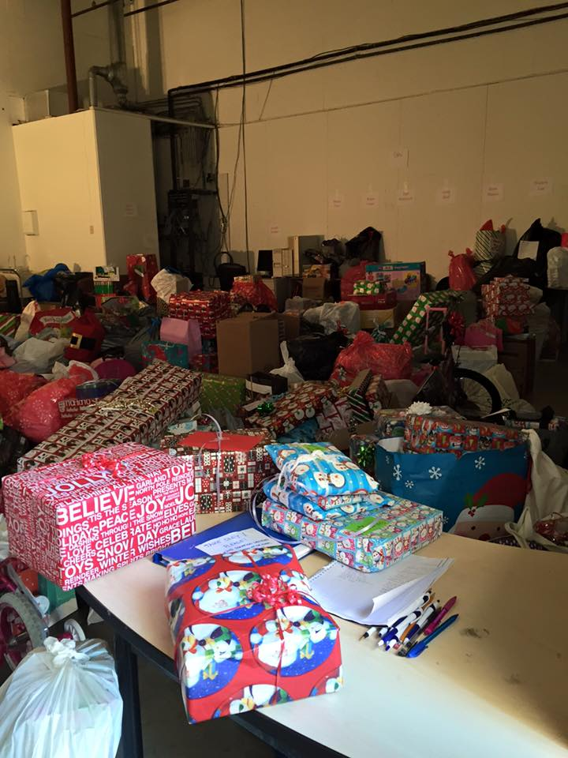
That’s when a friend recommended Child Advocates, Inc (Indy CASA), and told me how the organization could use help with their 2015 toy drive. Intrigued, I followed up on that lead and stumbled upon what literally reshaped everything. I was only mildly aware of Indy CASA’s presence within the Indiana DCS list of services, but by the fall of 2015, a new dream emerged. And thus, by teaming up with Indy CASA for their toy drive, while drawing upon my growing list of networking contacts with the Girl Scouts of Central Indiana, as well as local businesses, we assisted with the collection and sorting of all brands of toys which went to over 1,400 children!
Finally, at long last, we were able to reach children in a really big way. And based on the results of the toy drive, The Barbie Girls Project was revamped in 2016 – keeping its name, but adapting its mission of participating in as many efforts as we can to support the causes for children in Central Indiana, including Indy CASA’s toy drive. Since then, we’ve gone on to participate in a couple more holiday toy drives, but now we’ve found a few solid places to donate dolls to, both locally and around the USA. So whatever we give to girls and children in need, we do so in the spirit of what it means to be a Barbie girl, because:
“In the spirit of girl power and a can-do attitude for serving children in need, we call ourselves The Barbie Girls Project: an initiative to transform the lives of the underprivileged, one child at a time!” – Natasha Polak, founder of The Barbie Girls Project©.
Thank you for reading about our humble beginnings – we’d love to hear from you!
Connect with us today to stay updated with our latest happenings and to volunteer/donate:
- The Barbie Girls Project website: http://thebarbiegirlsproject.yolasite.com
- Facebook page: https://www.facebook.com/The-Barbie-Girls-Project-135528563210747/
- Twitter Feed: https://twitter.com/barbie_charity
SOURCES

http://www.cheerfulgivers.org/ provides needing children with birthday gift bags.
http://thebarbiegirlsproject.yolasite.com/ is our initiative to transform the lives of the underprivileged, one child at a time, founded in 2011.
https://en.wikipedia.org/wiki/Richmond_Hill_explosion “Richmond Hill Home Explosion”, November 10, 2012.
http://www.idealist.org/view/nonprofit/34GZ46x3kCWmD/ helps provide displaced families in Indiana with temporary provisions.
http://www.childadvocates.net provides court appointed child advocates for foster children with the Department of Child Services.

